|  |
| --- |
| 新东方在线英语学习 |
| 新概念 3 册 |
| Lesson1 |



扫一扫。更多有趣的英语资讯。

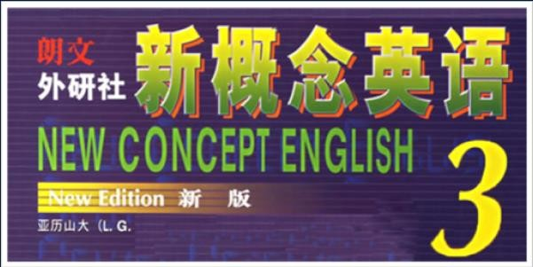

# 李延隆

新东方教育科技集团十大演讲师之一，集团 20 周年功勋教师奖得主，集团教学培训师，美国亚利桑那大学访问学者，北京新东方学校资深教师，原北京新东方学校英语学习部新概念英语大学项目经理，多次荣获北京新东方学校优秀教师称号。

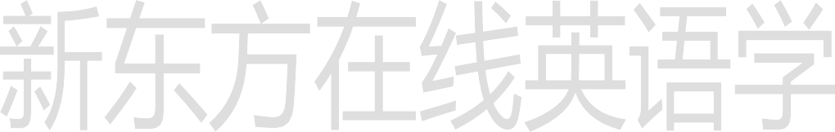博 客 ： <http://blog.sina.com.cn/liyanlong76>微 博 ： <http://weibo.com/liyanlong76>

微信：

liyanlong76

It is no use doing what you like; you have got to like what you do.

— Winston Churchill

# What am I supposed to do?



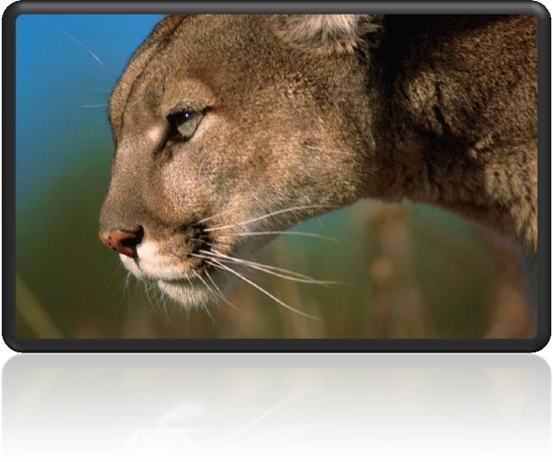**Lesson 1 A puma at large**

# spot [spɒt]

v. 看出，发现

stop lot hot

boss dog

a big red spot

a spot on one’s reputation

A leopard won’t change its spots.

# spot of sth.

a spot of bother 一点麻烦

You seem to be having a spot of bother with your car, can I help?

# a scenic spot 景点

A great many of scenic spots are being spoil by the ill-behaved tourists. The Middle East is a hot spot.

# on the spot 在现场

Four days after setting out, while the Titanic was sailing across the icy waters of the North Atlantic, a huge iceberg was suddenly spotted by a look-out.

Ten minutes after calling 911, a police car arrived on the spot.

Dr. Marcy and Dr. Butler also spotted the first “family” of three planets. Chick Webb spotted her in an amateur competition when she was sixteen.

Four days after setting out, while the Titanic was sailing across the icy waters of the North Atlantic, a huge iceberg was suddenly spotted by a look-out.

He had spotted a tiny bottle at the bottom of my case and he pounced on it with delight.

# see / find / observe

recognize sb. as …

In the torchlight, he caught sight of a figure whom he immediately recognized as Bill Wilkins, our local grocer.

# identify

ID card ➔ identity card

UFO ➔ unidentified flying object

# evidence ['evɪdəns]

n. 证据

a piece of evidence

evident

self-evident

All truth passes through three stages. First, it is ridiculed. Second, it is violently opposed. Third, it is accepted as being self-evident.

— Arthur Schopenhauer

Declaration of Independence

We hold these truths to be self-evident, that all men are created equal, that they are endowed by the Creator with certain unalienable rights, that among these are life, liberty, and the pursuit of happiness.

― Thomas Jefferson

# Court 法庭

go to court 打官司

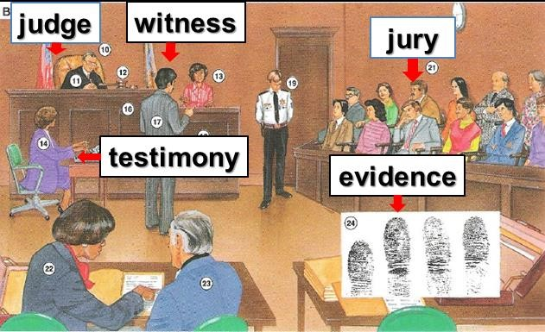settle sth. out of court 私聊

accuse sb. of (doing) sth.

I accused him of stealing my sheep. charge sb. with (doing) sth.

I charged him with stealing my sheep.

# accumulate [ə'kju:mjəleɪt]

v. 积累，积聚

accumulate knowledge / possessions

I accumulated a large vocabulary. amass amass a fortune People tend to amass possessions.

pile up

Meanwhile, the traffic piled up behind.

collect collect stamps

gather gather hoard

Shenzhen real estate developers hoard large amounts of land.

# oblige [ə'blaɪdʒ]

**v. 使……感到必须**

obligation

be / feel obliged to do =must do = have to do =be / feel impelled to do

Thank you very much for having offered me such a golden opportunity to work as an editor for Designs & Fashions, a best-selling magazine renowned for its extraordinary quality and taste. I was thrilled by the news and have tried my utmost, but after two months’ work I feel obliged to resign, which is truly a tough decision for me.

be / feel compelled to do

President Nixon felt compelled to resign. be / feel impelled to do

He felt impelled to point out that they were making a dangerous mistake.

# human being ['hju:mən 'bi:ɪŋ]

n. 人类

human being man

mankind humankind

human race humanity a crime against humanity

alien being intelligent being

To be, or not to be: that is the question.

— Hamlet

I think therefore I am.

# corner ['kɔ:nə(r)]

— René Descartes

# v. 使走投无路，使陷入困境

Don’t corner me!

A cornered beast will do something desperate.

on / in / at / around the corner

My birthday is just around the corner.

# convince [kən'vɪns]

**v. 使……信服**

convince sb. of sth.

He failed to convince the jury of his innocence.

cure sb. of sth.

The doctor cured him of his lung cancer.

inform sb. of sth.

My ex-wife informed me of her marriage.

remind sb. of sth.

You remind me of one of my classmates.

rob sb. of sth.

The robber robbed me of my wallet.

deprive sb. of sth.

Some criminals were deprived of political rights.

assure sb. of sth.

The dealer assured me of its quality.

# somehow ['sʌmhaʊ] adv. 不知怎么搞地， 不知什么原因

And I couldn’t remember what it felt like when I could not walk down the street without holding her hand.

I mean she was the same woman I fell in love with, she hadn’t changed. But somehow everything’s different. We've lost something along the way.

# somewhat

He was somewhat hungry.

He was somewhat embarrassed.

# somewhere

I’ve lost my wallet somewhere around here.

# disturb [dɪ'stɜ:b]

**v. 打扰，令人不安**

Do not disturb.

I hope I'm not disturbing you.

Sorry to disturb you, but …

Sorry to disturb you, but I really need your help.

at large

a puma which was at large

a prisoner / suspect at large

The disease is still at large.

bear-like animals

lady-like behavior child-like simplicity

an angel-like girl crystal-like eyes

flu-like symptoms

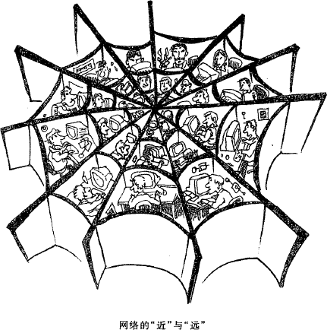

As is shown in the picture, there is a cobweb-like structure with separate compartments packed in it.

Foxes and farmers have never got on well. These small dog-like animals have long been accused of killing farm animals. *(CET-4)*

Pumas are large, cat-like animals (which are)found in America. be found in …产于

Many plant and animal species are found only in the rainforests. Vitamin C is found in citrus fruit.

造句: 大熊猫 (giant panda) 是一种大型的，类似于熊的动物，产于中国四川省。

He came into the classroom.

无灵主语 / 物称主语

(inanimate subject)

I thought of a good idea.

A good idea came into my mind.

A good idea flashed into my mind.

He went to the town on business.

Business took him to the town.

A warm and sunny Sunday found my whole family going for an outing at the beach.

# 同位语从句和定语从句的区别

1、从定义上看：同位语从句解释前面名词的具体内容；而定语从句仅起到后置定语的作用， 常译为“……的”。

2、从形式上看：同位语从句中的“that”仅起到连接符号的作用，不充当语法成分；而定语从句中的“that”是关系代词，在从句中充当主语、宾语或表语。

The proposal that John should be dismissed is unacceptable.

The proposal that John put forward is unacceptable.

We hold these truths to be self-evident, that all men are created equal, that they are endowed by the Creator with certain unalienable rights, that among these are life, liberty, and the pursuit of happiness.

― Thomas Jefferson

had been seen / found / observed …

in / on / to the south of …

Shanghai is in the south of China.

Vietnam is on the south of China.

Indonesia is to the south of China.

100 kilometers south of Xi'an

take … seriously take … lightly

… they were taken lightly.

When *reports* came into London Zoo *that a wild puma had been spotted forty-five miles south of London*, they were not taken seriously.

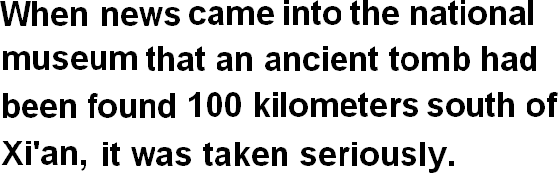造句：当消息 (news) 传到了国家博物馆 (the national museum)，说是在西安以南 100 公里处发现了一座古墓 (an ancient tomb) 的时候，这则消息受到了重视。

however

D:\nce3 ppt\图片库\trafficlight06.gif

investigate the market investigate the case

because

since

as for

in that now (that)

Now that a tunnel has been built through the mountains, the Pass is less dangerous, but each year, the dogs are still sent out into the snow whenever a traveller is in difficulty.

give descriptions

descriptions which were given by people …

make descriptions

… descriptions made by people …

The hunt for the puma began in a small village where a woman picking blackberries saw a large cat only five yards away from her.

John had a very good day and put his wallet containing ₤3,000 into the microwave oven for safekeeping.

For hundreds of years, St. Bernard dogs have saved the lives of travellers crossing the dangerous Pass.

novels written by Lu Xun

movies directed by Zhang Yimou

The man claim to have done …

claim to do …

So far, no organization has claimed to be responsible for the accident.

Be supposed to have done

Everyone went to the funeral, for the 'ghost' was none other than Eric Cox, a third brother who was supposed to have died as a young man.

Be thought to have done

When I was a boy, my grandfather told me how a German taxi driver, Franz Bussman, found a brother who was thought to have been killed twenty years before.

extraordinarily primarily absolutely necessarily temporarily

were extraordinarily similar were particularly alike

had a lot in common

had considerable commonalities

—well, I saw the ad on the back of the bus stop today. And, uh… though it was not exactly like looking in the mirror, you can't deny that there is a certain commonality in our visages.

—I guess we do look a little bit alike.

However, *as the evidence began to accumulate*, experts from the Zoo felt obliged to investigate, for the descriptions *given by people who claimed to have seen the puma* were extraordinarily similar.

造句: 随着病例 (case) 开始慢慢增多, 医学专家们 (specialist) 觉得必须要调查了,因为得了这种病的人的症状 (symptom) 特别地相似。

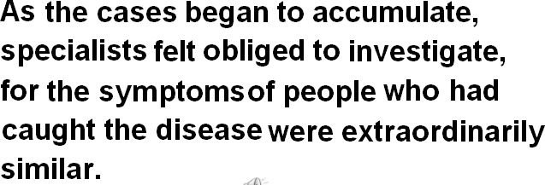

hunt for …

I’m hunting for a job now.

The hunt for a job will begin tomorrow. the winter in America

the entrance to the parking lot

a witness to the accident

a longing for love

the reason for the disaster woman villager

[w] [v] just … merely …

no more than …

confirm 证实说

President Hu Jintao confirmed that he would visit the United States next month.

prove (to be) + adj. / n. 被证明是……

His injury proved (to be) fatal.

The operation proved (to be) a success.

turn out to be + adj. / n. 原来是……

When the archaeologists reconstructed the fragments, they were amazed to find that the

goddess turned out to be a very modern-looking woman.

疑问词 + ever (whenever, wherever, whoever, whichever, whatever ...) 有两个含义：

1. 表示“无论……”引导让步状语从句。

= no matter + 疑问词

No matter where it went, …

No matter where you live, you would find it difficult not to laugh at, say, Charlie Chaplin's early films.

1. 表示 “到底……” 用于疑问句中。

'Whatever are you doing up here Bill?' asked the vicar in surprise. Wherever did you go yesterday?

Whenever am I going to see you again?

1. These things take time to learn.
2. Will you study anymore?
3. Why do you keep on making the same mistakes?
4. It will be a good learning experience for you. When will you ever learn?

Answer: (C) Why do you keep on making the same mistakes?

Wherever it went, it left *behind it* a trail of dead deer and small animals like rabbits. a trail of

Wherever he went, he left a trail of … behind him. Wherever he went, he left a trail of unpaid bills behind him.

Wherever he went, he left a trail of broken hearts behind him.

人们对下岗工人的生活状况越来越关注了。

People have paid more and more attention to the condition of the laid-off workers.

Increasing attention has been paid to the condition of the laid-off workers.

complain of / about sth.

claim

confirm

Then I added with a smile, ‘It’s a strange mixture I make myself.’…,

as one of them put it ‘ate like kings’.

The writer stated that Rastus was in safe hands …

on a business / honeymoon trip

on a journey / voyage / expedition / tour …

# President Xi Jinping is on a five-nation tour.

be convinced that …

convince sb. of sth.

in that …

except / but that …

After telling several of his friends about the theft, Dimitri found out that his neighbour, Aleko, had suddenly acquired a new lamb.

He was a WOMAN!

must have done

You must have been ill yesterday.

You looked so pale.

must do

She knew that it must be the baker.

may / might have done

can not / could not have done

You can’t have been ill yesterday. I saw you going shopping with your wife.

The girl asked to see a timetable, feeling sure that her father could not have made such a mistake.

should / ought to have done

should not / ought not to have done

You should have finished your work yesterday. I shouldn’t have shouted at you yesterday.

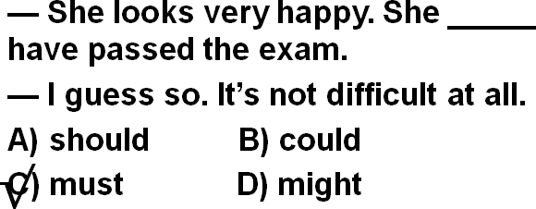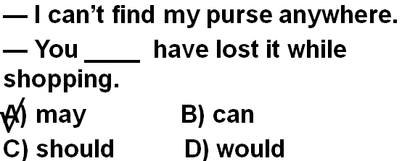

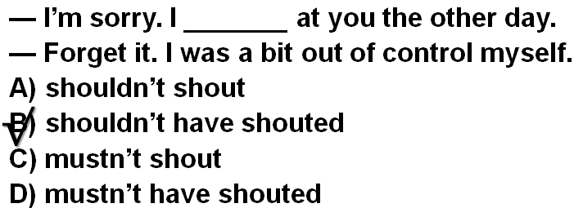

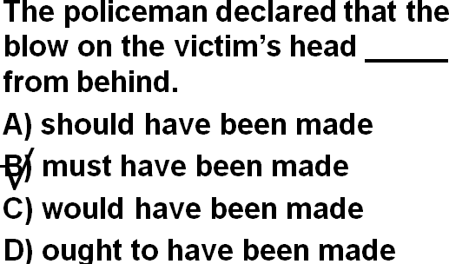

in the possession of sb. / in one’s possession

in possession of sth.

The book is in my possession .

I’m in possession of the book.

in the charge of sb. / in one’s charge in charge of …

The bookstore is in my charge .

I’m in charge of the bookstore.

manage to do 设法完成了某事

Our vicar is always raising money for one cause or another, but he has never managed to get enough money to have the church clock repaired.

fail to do 没能完成某事

When the journalist again failed to reply, the editor reluctantly published the article as it had originally been written.

*It* is disturbing *to think that a dangerous wild animal is still at large in the quiet countryside*. It is … to think that …

It is worrying to think that …

It is exciting to think that …

It is comforting to think that…

It is amusing to think that …

It is irritating to think that …